

**e-Yantra Robotics Competition - 2017**

**Theme and Implementation Analysis – Harvester Bot #2457**

|  |  |
| --- | --- |
| **Team leader name** | Rudra Narayan Pandey |
| **College** | Birla Institute of Technology, Mesra |
| **Email** | rudrakumar118@gmail.com |
| **Date** | 09 Jan. 18 |

**Scope and Preparing the Arena**

**Q1 a. State the scope of the theme assigned to you. (3)**

It is well known that agriculture has been the soul of the Indian economy since decades. However, the obsolete agricultural technologies results in a drastic downfall of the overall productivity. So, the introduction of harvester bots in the industry to harvest the fruits, as well as, sort the collected fruits based on its size and quality using computer vision programs assist the farmers of our country. It is good that the potential in fruit harvesting can now be exponentially availed and can be beneficially put up for increased productivity, reduced costs, machined aids, etc to ultimately boost the Indian economy.

1. **Attach the Final Arena Images. (20)**

< Prepare the arena according to the steps given in Section 3: Arena, of the rulebook. Please follow the sub-section 3.4--Arena Configuration to prepare the arena which should resemble “Figure 7: Final Arena” of the rulebook.

Take 4 photos of the completed arena from different angles such that the entire arena along with arena components such as Trees, Fruits, Cavities etc., are clearly visible in the photos.

The four image files should be uploaded along with this document.>

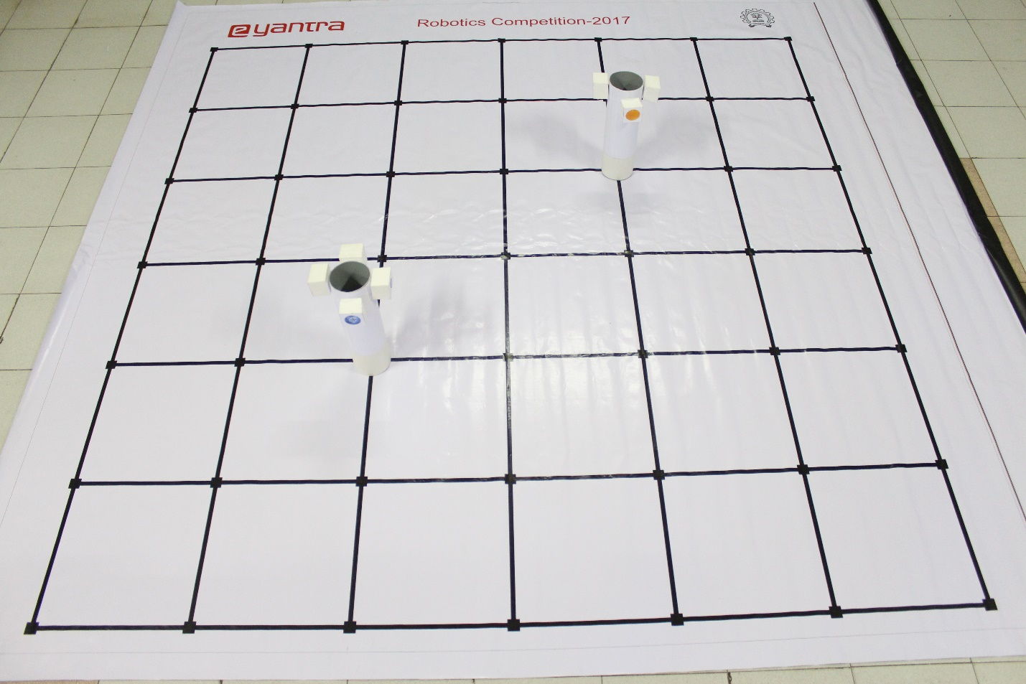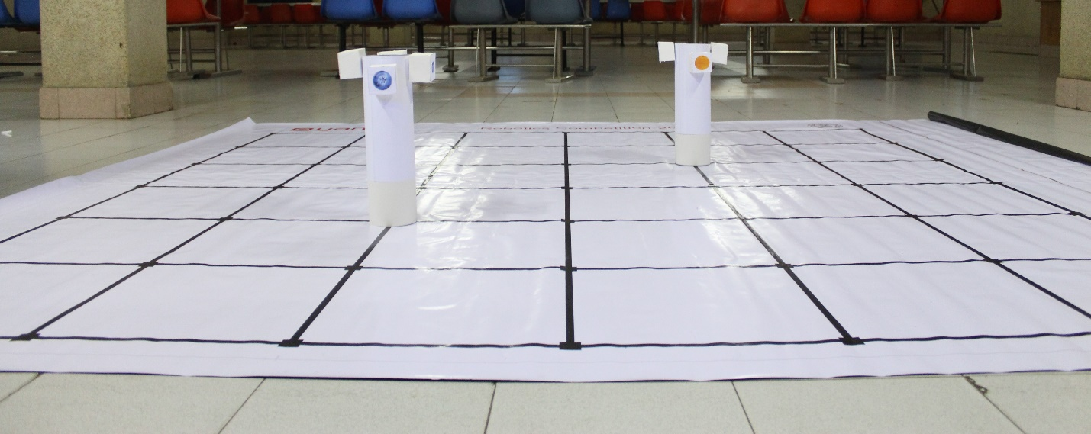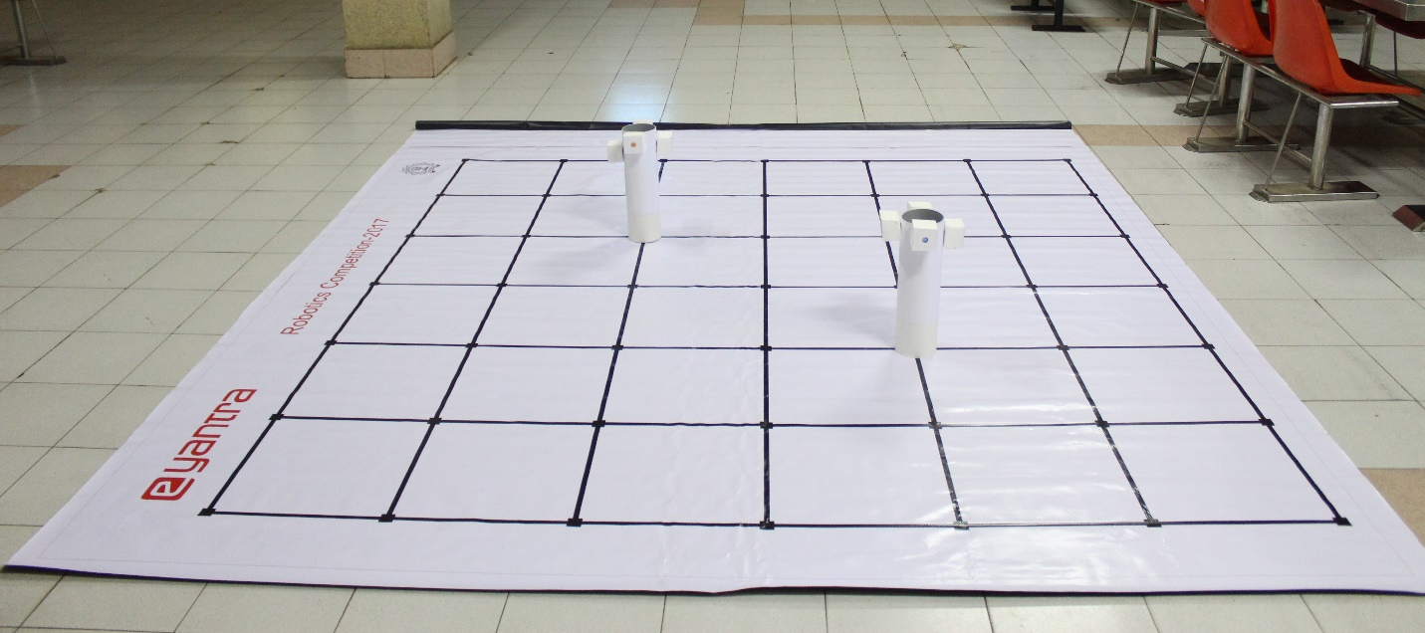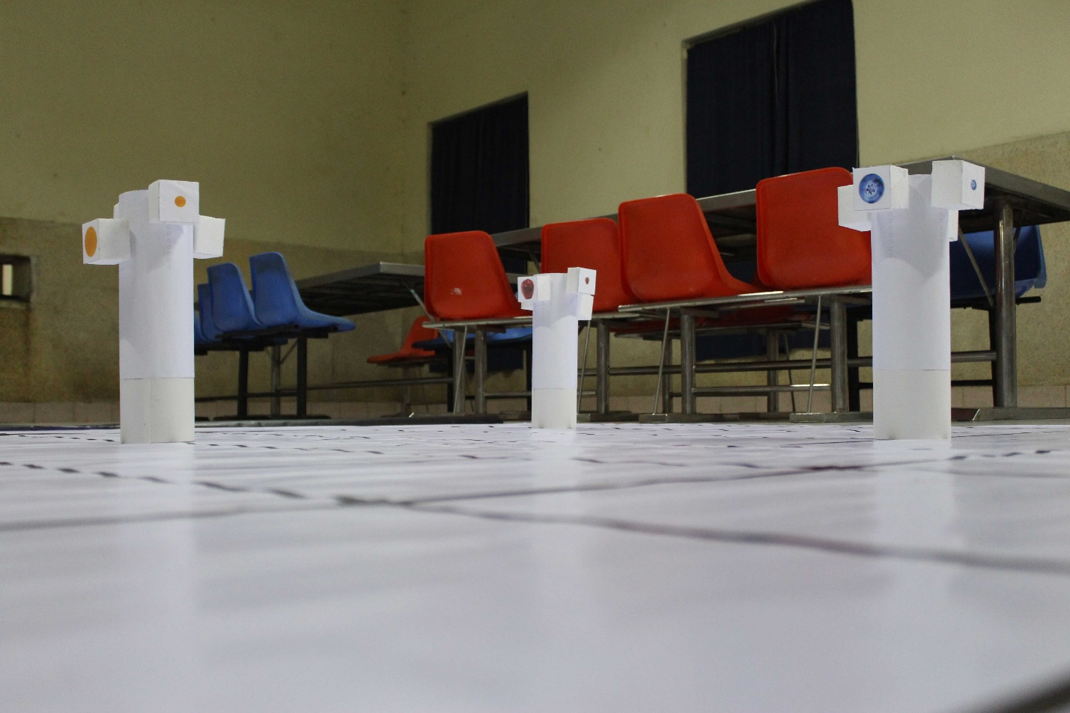

**Building Modules**

**Q2. Identify the major components required for designing the robotic system for the solution of the theme assigned to you.**

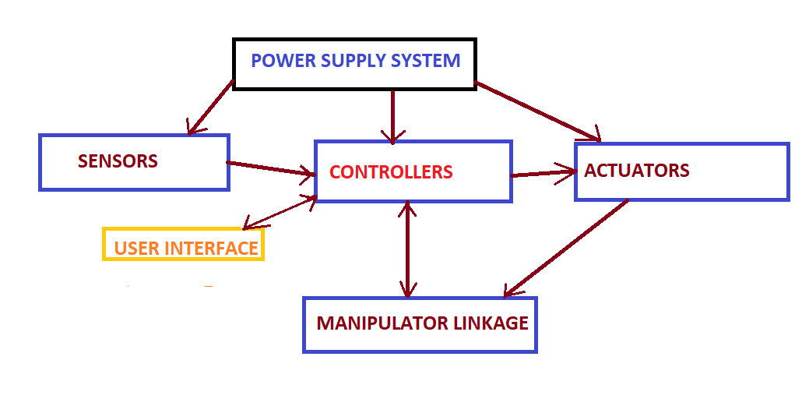 **(5)**

**ACTUATORS: -**

• DC MOTORS-DC Motors are used for arena traversal of the robot

• SERVO MOTORS- Used for controlling motion of robotic arm gripper and fruit container

**SENSORS: -**

• WHITELINE SENSORS: -Whiteline sensors are used in line following of the robot.

• SHARP SENSORS :-It is used to sense how far the fruit tree is from the robot.

• POSITION ENCODERS: - It gives us the distance travelled by the robot and that value is needed to stop the robot at a threshold distance from the tree.

• CAMERA: - The camera captures the image of the fruit for further processing of its shape and size.

**POWER SUPPLY SYSTEM**-

FIREBIRD V is powered by 9.6V, 2.1Ah rechargeable Nickel Metal Hydride battery pack.

**ELECTRONIC SYSTEM AND CONTROLLERS: -**

• RASPBERRY Pi 3-The Raspberry Pi 3 is used for all image processing tasks. Also, the position of the deposition zones and the trees will be fed into the Raspberry Pi and accordingly the Firebird will be made to perform actions via Raspberry Pi-Firebird V interfacing.

• FIREBIRD V-Used for all controlling and decision-making actions of the robot

**MECHANICAL SYSTEM (MANIPULATOR AND LINKAGES): -**

• ROBOTIC ARM

• GRIPPER

The robotic arm with gripper is used for gripping and placing fruits in the container.

**Actuators**

**Q3. List all the actuators present on Firebird V robot. Besides the existing actuators, please mention any additional actuators that may be required for designing the theme. (5)**

**Inbuilt :-**

• Two 75 rpm DC geared motors- Fire Bird V robot has two 75 RPM DC geared motors in differential drive configuration along with the third castor wheel for the support. Motors are controlled by L293D dual motor driver.

The DC geared motors will be used for traversing the arena following the black line and the motors will also be stopped at a threshold distance decided by the feedback given by the position encoders mounted on both the motor’s axle to give position feedback. 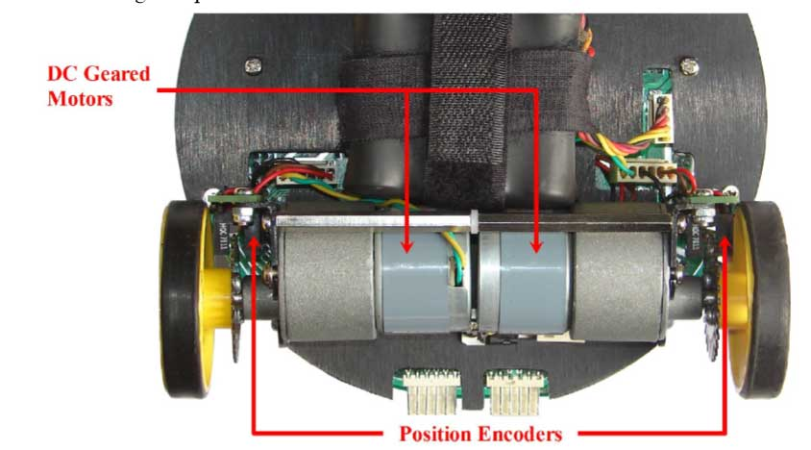 **Adds on:-**

• 2 Servo motors-The two Servo motors provided in the kit will be used to give the robotic arm the precise angle

• Extra actuators used(not in the kit provided):- 1 SERVO MOTOR:- This servo motor will be used for tilting the fruits container in the deposition zone.

**Power Management (2)**

**Q4. Explain the power management system required for a robot in general and for the autonomous robot you are designing in particular.**

We are using 9.6V, 2.1Ah rechargeable Nickel Metal Hydride battery pack to power the Firebird. 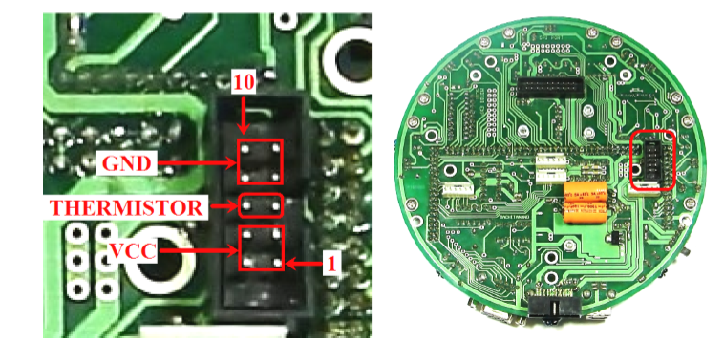

FIG: -BATTERY CONNECTED ON MAIN BOARD

•Servo motors: The servo motor requires 5-10 volts supply and 0.5-1amp of current depending on its application

•DC motors: The L293D IC is a motor driver IC which is used to provide a maximum of 600 mA of continuous and 1A of starting current to the two motors.

•Sensors: “5 V system” is used to power various sensors on robot

•A 3.3 v supply is used to power the white line sensors with an additional supply capacity of 100mA.

**Design Analysis**

**Q5.** **Teams have to design a mechanism for identifying, plucking and depositing the Fruits in the Deposition Zones.**

1. **Choose an** **option to position the mechanism on the robot and why? (3)**
2. **Front 2. Back 3. Right/Left**

**Answer: ____________________**

For identifying the fruit, a camera needs to be present for capturing photos. To ensure its successful operation it has been placed in the front of the robot such that its field of view is not widespread and the focus is on the captured size of block. It has not been placed on the left/right side so as to get a proper image of the face of the fruit of block. Otherwise, the image of fruit won’t be of proper shape.

The gripper arm has also been placed in the front such that the distance between the block and arm is not very large. This will minimize the size of arm to be used and we won’t have to turn the bot for plucking the fruit.

The fruit bucket has been placed on the back so as to not obstruct the view of sharp sensor present on Firebird V and prevent any accidental collision between the robot and trees. It has not been placed on left/right to minimize the complexity of movement of the gripper arm and also for proper weight distribution on the robot so that the robot is stable.

1. **Explain the design of the mechanism and how it is mounted on the robot. (7)**

The design of the robot can be seen below in the diagram. The final design will approximately resemble the mentioned design. In this, the Raspberry Pi and a power bank connected to it are kept on top of the Firebird V robot. On top of this arrangement, a separate layer has been created for the gripper arm mechanism and for mounting the camera. The camera is mounted on top of a pole in the front of the robot, displaced by a certain distance from the central line passing through the sharp sensor. Beside this pole is a servo motor connected with the Firebird V to control the gripper arm for plucking the fruit. The servo motor is placed directly above the castor wheel. On the back of the robot, a self designed bucket(fruit container) has been attached to a servo motor, to temporarily store the plucked fruit. This servo motor is used to tilt the bucket, so as to drop the fruits when near the deposition zones.

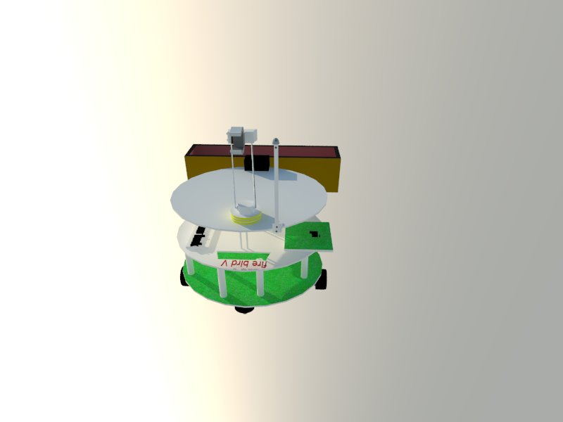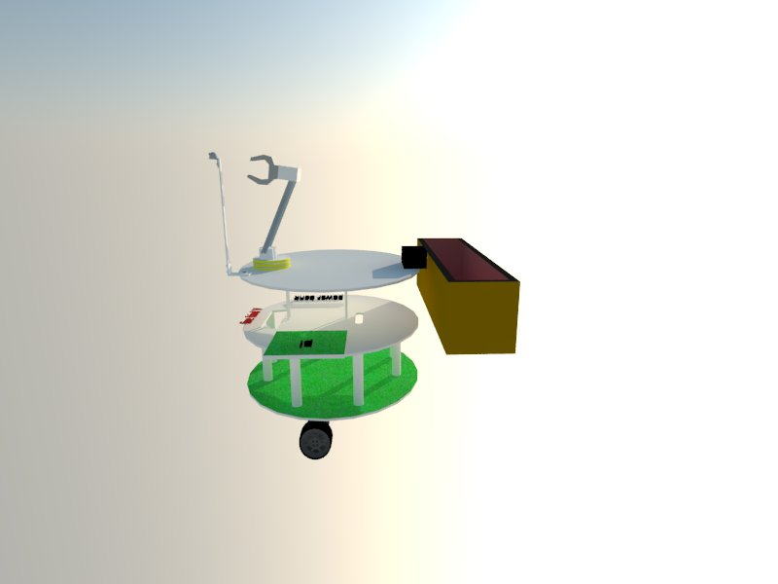

1. **To design the mechanism for identifying, plucking and dropping the Fruits, what challenge/s do you expect to face and how you will overcome them? (2)**

Challenge: Finding contour of the fruit

Solution: Proper research and testing will be done to write the algorithm for identifying the contour of the fruit along with its colour.

Challenge: Setting the angle of servo motor

Solution: We will find the elevation of fruit from the table and then adjust the angle of the arm accordingly. The angles required will be found when testing the robot on the arena.

Challenge: Fruits should be deposited only in the deposition zones

Solution: We will rotate the bucket at such angles such that the fruits don’t fall outside the deposition zones. We will test the rotation at different angles and speeds so as to find the best possible angle and speed.

**Q6. Choose the actuator/s you will use to design the mechanism. (2)**

1. **DC-Motor 2. Servo Motor 3. Stepper Motor 4. Others**

**Answer: _________________**

1.DC-Motor- We will use 2 DC geared motors with position encoders mounted on its shaft to traverse the arena along the black line. The feedback from the position encoders will be used to stop the robot at a given distance from the tree.

2.Servo Motor-We are using servo motor to position the robotic arm to an accurate angle for fruit gripping. Servo motors have inbuilt encoders attached to them which gives position feedback hence appropriate to control the arm.

3.Stepper motors are not used because it doesn’t have encoders in them that can give position feedback. The stepper motor’s design results in torque degradation at higher speeds as compared to servo.

**Environment Sensing**

**Q7. Explain how you will use the provided sensors to implement the theme. (5)**

**Whiteline Sensor:**

Transmitter: -RED LED

Receiver: -Phototransistor

Mechanism: -. When the robot tracks the whiteline more amount of light gets illuminated in the path and therefore leakage current is high, while on a dark surface the amount of light amount of light reflected is less hence less leakage current flows through the photo transistor.

LOCATION: -An array of 3 whiteline sensors are provided on the platform. It is placed on the front part of the firebird platform just behind the castor wheels. It is placed on the anterior end so that the path can be sensed before the bot gets on the path.

**CONCEPT OF WHITELINE SENSOR**

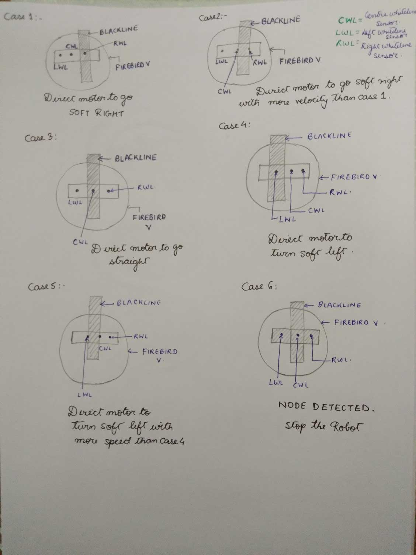

**FLOWCHART FOR LINE FOLLOWING USING PID**

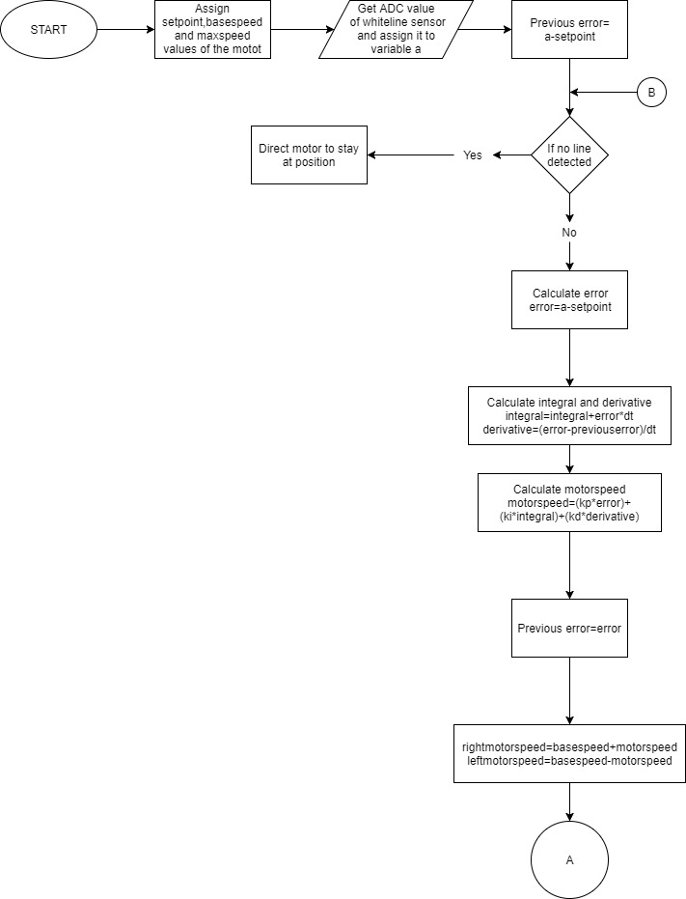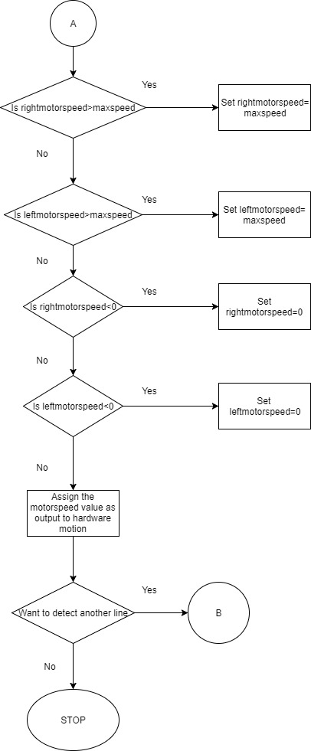

**2)SHARP RANGE SENSOR**

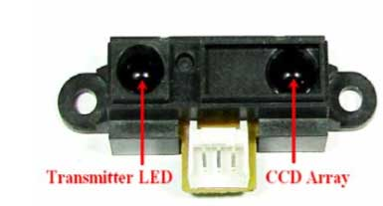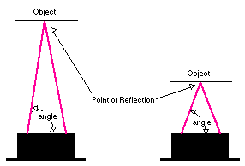

TRANSMITTER: - IR RAY

RECEIVER: -CCD ARRAY

When an object comes in front of the robot infrared light emitted from the sensor strikes the object and is reflected back. This reflected ray is received by array of the CCD at the receiver side. It gives same response to different coloured objects as measured distance is function of the angle of reflection and not on the reflected light intensity

ADVANTAGE: Since sensor measurement is based on triangulation and not on intensity of the reflected light, it is immune to disturbance caused by ambient light. It has a good range from 10-80cm.We are using sharp sensor because it has good range and precision.

LOCATION: - It is placed on the anterior part of the robot along the edges of the robot so that it senses the distance of the obstacle first and accordingly the robot adjusts its’ position. Our robot has only one sharp sensor placed in position 3 as shown in the fig.

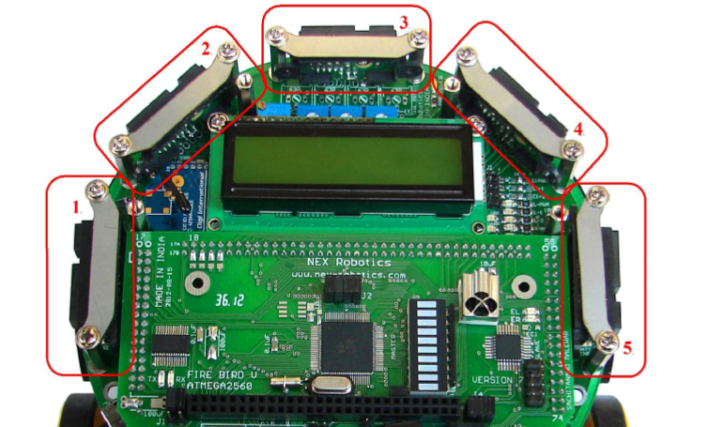

**3)POSITION ENCODER: -**

Position encoders are used in closed loop to control robot’s position and velocity. 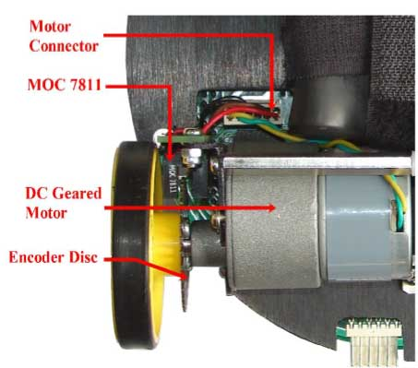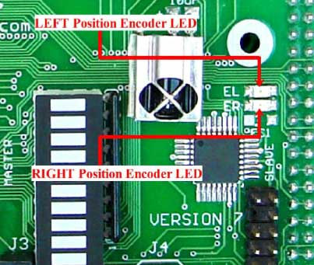

PLACEMENT: -Position encoder consists of a slotted encoder disc which is mounted on the wheel and is placed in between the slot of MOC7811. When encoder slotted disc rotates between the optical transmitter and the receiver, it cuts IR illumination alternately because of which photo transistor gives square pulse train as output. The pulse count can be used to calculate the position /distance travelled by the robot and dividing it with time period will give us the velocity.

USAGE:-In our robot we will use position encoder to find the position of our robot and accordingly stop our robot at a threshold distance from the tree.

**Communication**

**Q9. Describe the method/s of communication between:**

1. Firebird V robot and Raspberry-Pi
2. Computer and Raspberry-Pi  **(10)**

Communication between Firebird V and Raspberry Pi 3 can be done in many ways, the protocol which we are using for communication is UART.UART or Universal Asynchronous Receiver Transmitter is a method of asynchronous serial communication between two microcontrollers. In UART communication, two UARTs communicate directly with each other.

ALGORITHM FOR COMMUNICATION BETWEEN TRANMITTER UART (RASPBERRY PI 3) AND RECEIVER UART (FIREBIRD V)

1. START

2. Transmitter UART receives data from the data bus in parallel form, by another device like CPU.

3. The transmitter UART adds start bit in the beginning of the 5-9-bit long data to mark the beginning of the data.

4. The transmitter UART adds a parity bit at the end of the data which is set to 1 if there is a change in data during transmission or else it is assigned 0.

5. To signal the end of the data packet, the sending UART drives the data transmission line from a low voltage to a high voltage for at least two-bit durations

6. Set the stop bit to synchronize the transmitter with the receiver.

7. The data packet is output serially bit by bit at the Tx pin.

8. The receiving UART detects the start bit and it starts reading data at the same baud rate at which the data was transmitted (115200 bits per second for raspberry pi)

9. The receiving UART reads the data packet bit by bit at its Rx pin.

10. The receiving UART then converts the data back into parallel form and removes the start bit, parity bit, and stop bits.

11. The receiver samples the line 16 times in the bit cell time to determine its value thereby avoiding a noise pulse from triggering a false data read

12. The receiving UART transfers the data packet in parallel to the data bus on the receiving end.

13. STOP

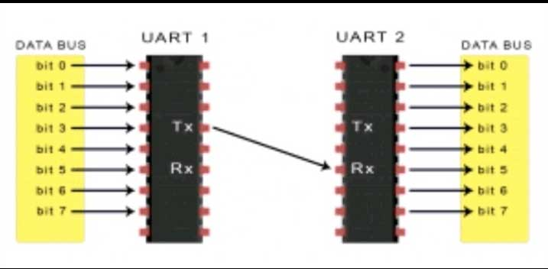

**B) Communication between Computer and Raspberry-Pi**

Communication between raspberry pi and computer can be made by many method, and we need communication because information exchange between a program running on the Raspberry Pi and a partner program running on a remote computer system becomes important when the Raspberry Pi is a front end of a measurement system and transfers sensor data in real-time to a control station or when a remote PC sends commands a RPi based robot (remote control mode). And as we need wireless communication between them to serve our purpose, this communication will then govern by Network, protocols

Networking protocols exist in layers, each layer wrapping the information in the next; the information in the IP layer is what allows one system to get a message to another. The next layer of information is (almost always) TCP, which govern some things about the how messages are packaged for transmission and includes a port number, which is an address internal to the system ,since the system may have various concurrent but unrelated channels of communication going on via the same physical connection.

•Transmission Control Protocol/Internet Protocol (TCP/IP) is the language a computer uses to access the Internet. It consists of a suite of protocols designed to establish a network of networks to provide a host with access to the Internet.

TCP/IP is responsible for full-fledged data connectivity and transmitting the data end-to-end by providing other functions, including addressing, mapping and acknowledgement.

TCP defines how applications can create channels of communication across a network. It also manages how a message is assembled into smaller packets before they are then transmitted over the internet and reassembled in the right order at the destination address. TCP handles communications between hosts and provides flow control, multiplexing and reliability.

IP defines how to address and route each packet to make sure it reaches the right destination. Each gateway computer on the network checks this IP address to determine where to forward the message.

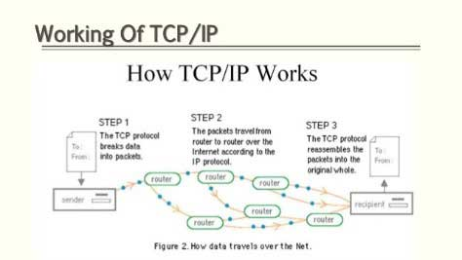

**Testing your knowledge (theme analysis and rulebook-related)**

**Q10. How will you identify the Fruits based on Required Fruits table? (4)**

•The bot will take a picture of tree when stopped before it.

•The image will be processed to find contours in the image.

•Bounding boxes will be drawn for each contour and the areas will be found.

•The fruit block will be detected by comparing the contour area with a threshold range (the range will be found after initial testing)

•When the block is found the bounding rectangle will be written as a new & separate image for further processing.

•This image will be resized to match the sample images.

•The image will be blurred using cv2.medianBlur() and more noise will be removed by using erosion techniques.

•The image will be processed again to find contours in the image.

•An upper & lower limit of contour area will be saved so that all other areas outside this range will be neglected.

•Within this range, three different ranges will be predefined for finding the size of fruit i.e. max, large and small.

•To find the colour of fruit we will create a bounding rectangle of the found fruit contour. A function will return the length and breadth of rectangle along with co-ordinates of point shown below.

•Then we will move downward from the pixel co-ordinate shown below and will find a point where the colour value changes sharply. This colour value will be stored for identification purposes.

•The type of fruit will be identified by three different colour ranges for each fruit (found after initial testing).

•Finally, the size and type of fruit will be stored and displayed on the terminal. 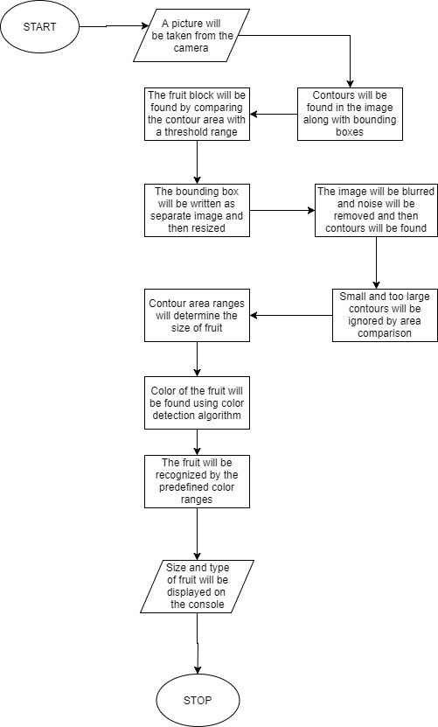

**Q11. Given the following Required Fruits table:**

|  |  |  |
| --- | --- | --- |
| **S. No.** | **Fruit** | **Size-Count** |
| 1. | Apple | -- |
| 2. | Blueberry | -- |
| 3. | Orange | L-3, M-1, S-1 |

**explain your approach in identifying and plucking Fruit/s in a Tree that has:**

1. **Fruit only on 3 sides (2)**
2. **no Fruit (2)**

Assumption- Only a single tree has been considered for this question and the e-yantra logo is assumed to be north

• The bot will traverse and face the suitable side of tree

• It will search for the fruit on this side.

• If a fruit is found then the bot will save the size and count of fruit. Then the bot will pluck the fruit by sending suitable instructions to the Firebird robot.

• If a fruit is not found then it will move to the next side of tree in clockwise manner. In this case, the plucking mechanism will be skipped.

• This process will be repeated for all four sides.

• At the end, if the number of fruits is found to be less than mentioned in the required fruits table then the Raspberry pi will display a message that “Some fruits are missing from the tree”.

• If no fruits are found then the message displayed will be “All fruits are missing from the tree”

**Q12. Explain in brief the navigation algorithm you will use for traversing of the arena. (3)**

For traversing the arena, we will be using shortest path technique, which will decide how the robot will reach the adjacent node of tree or nodes of deposition in lesser time and once the robot reaches the adjacent node of tree then depending upon the 3 cases (which is,

Case1: when tree is placed at left most/top most node of arena.

Case 2: when tree is placed at right most/bottom most node of arena.

Case 3: when tree is not present on the boundary node of arena.) bot will move around the tree to pluck the fruits accordingly.

We will be using A*-algorithm (A Star) for finding the shortest path as it gives better result as compared to other methods when one source and one destination is present.

While applying A*-algorithm, we will be using 2 lists namely open list (basically fields that are considered for the path) and closed list (fields that do not need to be examined anymore) and then we will be calculating the cost for each traversal from one node to other.

Fcost=Gcost+Hcost

G-Cost: The cost of walking from the start to the current field.

H-cost:

” Heuristic”: Estimated cost from current field to target.

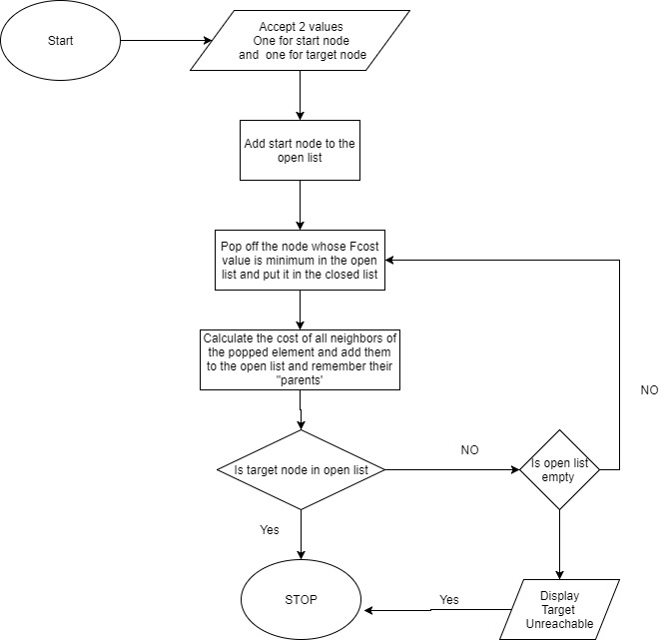

The basic structure of A*-algorithm is shown above.

**Algorithm Analysis**

**Q13. Draw a flowchart illustrating the algorithm you propose to use for theme implementation.(20)**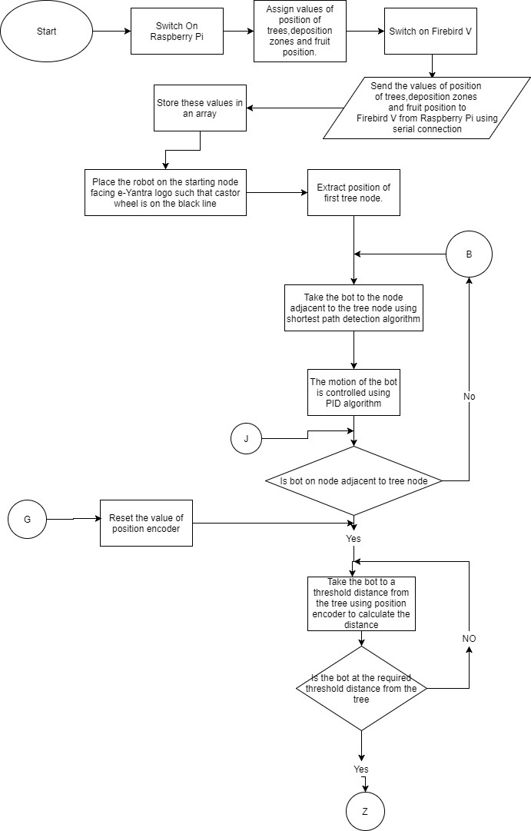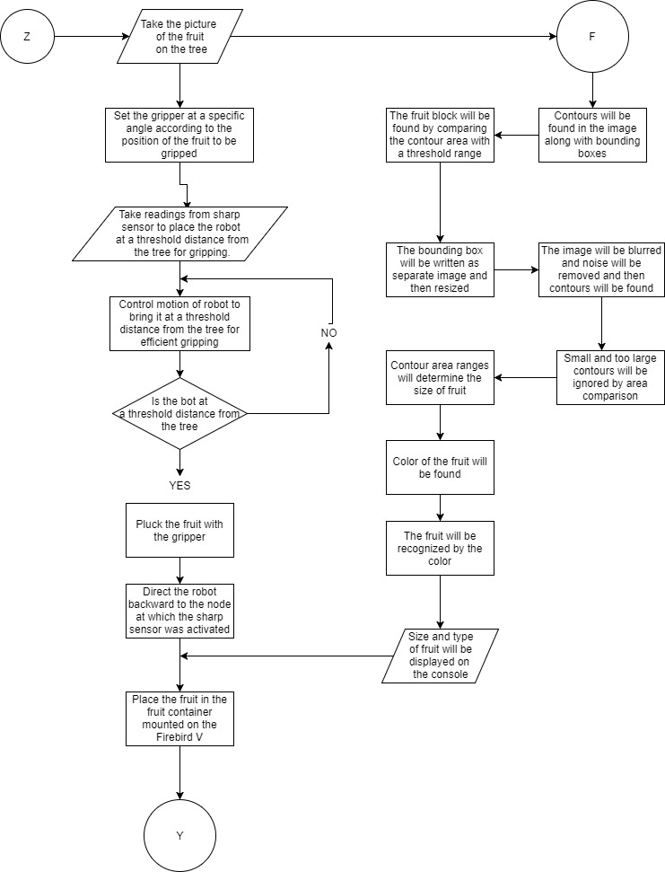

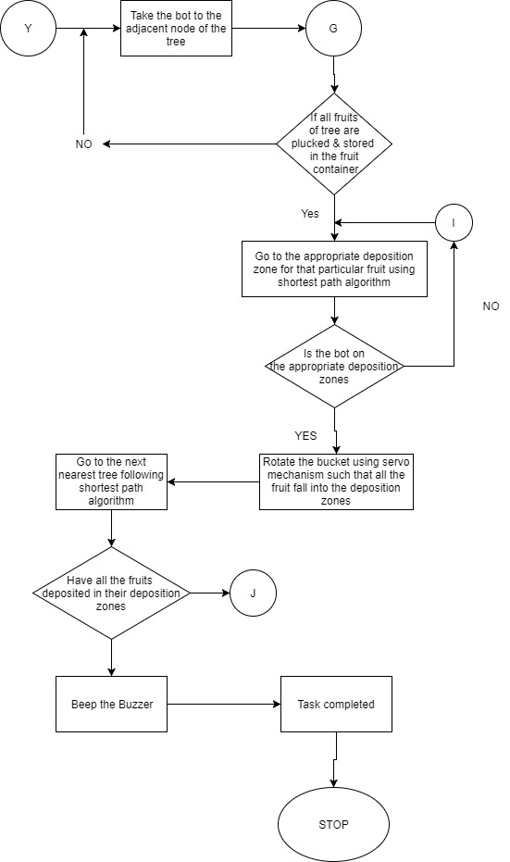

**Challenges**

**Q14. What are the major challenges that you can anticipate in addressing this theme and how do you propose to tackle them? (5)**

1.Challenge 1- A big challenge is to build a robust, flexible robotic arm. We will face difficulty in setting it at an accurate angle for gripping, Also, the gripper design should be effective for gripping.

2. Challenge 2- A major challenge will be faced in PID tuning for effective line following of the robot.

3. Challenge 3-The fruit container and the robotic arm has to be mounted keeping in mind the stability of the robot. The weight and size of the robotic arm and the container must be carefully chosen such that the purpose gets fulfilled and at the same time the robot does not topple.

4.Challenge 4- Since we would be using servos and sharp IR range sensors, we need to take into consideration their current and voltage ratings, and control their switching so that they are off when not in use thus preventing drainage of excess power.